1
Welcome to the Net

Homework
First Name:
Last Name:

Directions
For Test-Your-Understanding Questions
You must do all in boldface
You do not have to do those that are crossed out
You need to know others for the exam but need not do them as homework
You must do all End-of-Chapter Questions that are not crossed out
Omitting any will result in a severe reduction in your homework grade
Omitting or doing a careless job on any troubleshooting questions will result in a zero for the entire homework.
To answer a question part, place your cursor at the end of the question part and hit Enter
This will put you in the Answer style
Or, click on your answer and hit Alt-Ctrl-A
Save this file as 431 HW C01 yourname
E-mail it to panko@hawaii.edu.

Internet Basics
1. What is the significance of the Internet being depicted as a cloud?

2. a) What is the term we use in networking for any device that communicates over a network

b) Is your smartphone a host when you use it to surf the ‘Web
c) Describe the appearance of most servers today.
d) Are you as a person a host when you use a network?
e) Today, the Internet is used primarily by people working at client PCs. How will this change in the future?
f) What is this new trend called?
3. a) How do application programs on different hosts communicate?
b) If I call you on your cellular phone, do I have to know your name? (Think about this a second.)
c) What do I have to know?
d) What kind of addresses do hosts have on the Internet?
e) What kind of address is 128.171.17.13?
4. Use Excel’s dec2bin() function to convert from dotted decimal notation to binary. Convert each decimal number segment separately. The IP address in dotted decimal notation is 128.171.17.13. Put a space between each 8-bit segment to make your answer easier to read. Hint: 128 in decimal is 10000000 in binary. Hint: Be sure you have 32 bits in your answer.
5. Use the Excel bin2dec() function to convert the following 32-bit IP addresses into dotted decimal notation: 10101010 10101011 00001111 111110000. (Spaces added for ease of reading.) Hint: 10101010 is 170.
6 a) What type of IP addresses is 32 bits long?
b) What other type of IP address exists, and how long are its addresses?

The Internet
7. a) Is the Internet a single network? Explain.
b) What is the role of ISPs?
c) When do you capitalize internet?
d) Who controls the Internet?
e) Who funds the Internet?

Speed
8. a) Is network speed usually measured in bytes per second (Bps) or bits per second (bps)?
b) How many bits per second is 56 kbps without a metric prefix? (Check Figure: 56,000 bps)
c) How many bits per second is 376.2 Mbps without a metric prefix?
d) Express 47,300,000 bps with a metric prefix. (Check Figure: 47.3 Mbps.)
e) Express 87,011 bps with a metric prefix.
f) Why do you need to know what application you are using to know what connection speed you need?
g) Distinguish between speed to individuals and corporate network speeds.

Box: More on the Metric System and Speeds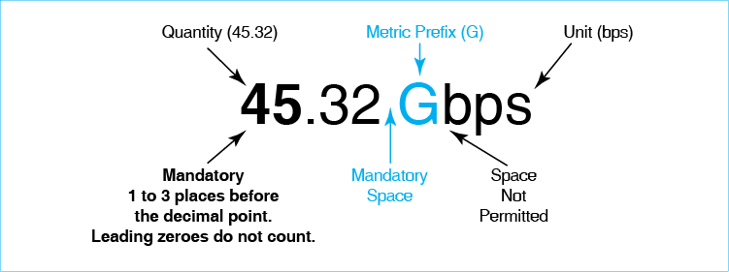

Quantity, Units, and a Mandatory Space
9. a) What are the three parts of a metric number?
b) What are the two parts of the unit?
c) Where is a space required in metric notation?
d) Where is it mandatory not to have a space?
e) Write 37kbps properly.
f) Write 89k bps properly.

Capitalization
10. a) When are unit names capitalized?
b) When are unit abbreviations capitalized?

Working with Quantities and Metric Prefixes
11. a) Write 50 kbps properly. (Check figure: 50,000 bps).
b) Write 56.780,000 m properly.
c) Write 0.25 s properly.
d) Write 0.25 Mbps properly.
e) Write 37,400 m properly.
f) Write 0.032 Mbps properly.

Messages

Application Messages

Message Fragmentation, Frames, and Packets
12. a) What is fragmentation?
b) What are frames or packets?
c) How does fragmentation improve transmission time through its error handling abilities?
d) What is multiplexing?
e) How does fragmentation reduce transmission cost through multiplexing?

Single Networks
13. What are the three defining characteristics of single networks?

Switched Single Networks
14. a) When a frame arrives at a switch, what must the switch decide?
b) How will it decide this?
c) Does a switch know a frame’s entire path through the network?
d) What do we call the path the frame takes from the source host to the destination host in a single network?
e) What do we call the path between two adjacent devices in a single network?
f) In Figure 1-13, how many physical links are there along the data link marked on the figure?
15. In a switched network, the source host sends a frame that will pass through four switches to reach the destination host.
a) How many physical links will there be?
b) How many data links? (Hint: Draw the picture.)

Point-to-Point Single Networks
16. a) In what type of network is there both a single data link and a single physical link?
b) What organization provides leased lines?
c) Why are leased lines important on the Internet?

Single-Network Host Addresses
17. a) Distinguish between IP and DL addressers.
b) What is the most widely used single-network DL address?
c) What else is it called?
d) Are all single-network addresses EUI-48 addresses?
e) In Figure 1-12, Destination Host Y has two addresses. What are they?
f) To which address of Host Y is the frame addressed?

Internets

Routes and Packets
18. a) How are frames and packets related in terms of encapsulation (when one message is placed inside another message)?
b) Create a table with three columns. The first is Description, the second is Single Network, and the third is Internet. Rows should have the descriptions Message Type, Address Type, and Forwarding Device. Fill in the table.
Description | Single Network | Internet
Message Type
Address Type
Forwarding Device

Frames and Packets
19. a) How are frames and packets related in terms of capsulation (when one message is placed inside another message)? (Yes, you have answered this question before.)
b) What does a router do when a frame arrives?

An Integrative Exercise
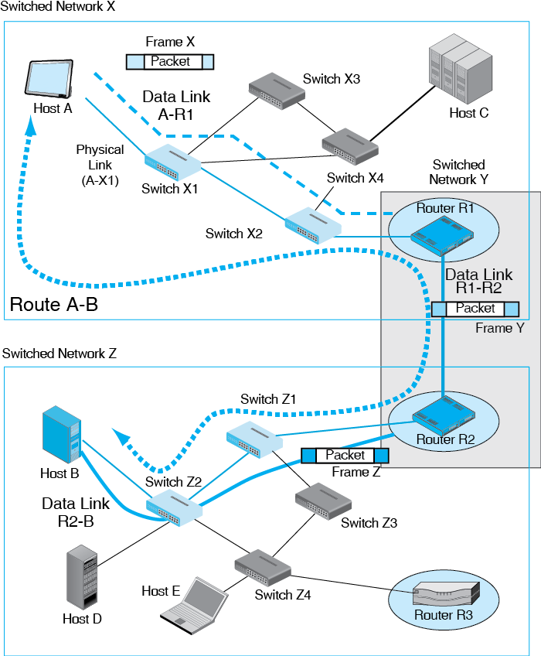
Test Your Understanding
20. a) When Host D in Figure 1-23 transmits a packet to Host C, how many physical links, data links, and routes will there be?
b) How many packets will there be?
c) How many frames? (Check answers are 7, 3, 1, 1, and 3).
d) When Host A in Figure 1-23 transmits a packet to Host C, how many physical links, data links, and routes will there be?
e) How many packets will there be?
f) How many frames?
21. a) To which address on which device will the packet be addressed?
b) To which address on which device will Frame 1 be addressed?
c) Frame 2?
d) Frame 3?

“Box: Packet Switching”
22. Both single switched networks and routed networks are said to use packet switching. Why is this term confusing?

Standards Layers

Five Layers

Layers 1 through 3 (Physical, Data Link, and Internet Layers)

Layers 4 and 5 (Transport and Application Layers)
23. a) What is required for competition among vendors?
b) What benefits do standards bring?
c) Name the five layers from bottom to top.
d) Give the number for each layer name.
e) What does Layer 1 standardize?
f) Layer 2?
g) Layer 3?
h) Layer 4?
i) Layer 5?
24. At what layer would you find…
a) Frames?
b) Routes?
c) Application message fragmentation?
d) Data links?
e) Wireless transmission
f) Packets
g) HTTP messages?

Standards Agencies and Architectures
25. a) Distinguish among ISO, OSI, and ITU-T.
b) In what two layers do OSI standards dominate?
c) What is the standards agency for the Internet?
d) In what two layers do its standards dominate?
e) What standards agency is dominant at the application layer?
26. Which standards agency produces standards for …
a) Frames?
b) Routes?
c) Application message fragmentation?
d) Data links?
e) Wireless transmission?
f) Packets?

TCP/IP Supervisory Applications: The Domain Name System (DNS)
27. a) To send packets to a target host, what must the source host know?
b) If the source host knows the host name of the target host, what must it do?

The Dynamic Host Configuration Protocol (DHCP)
28. a) When a client boots up, why does it need a DHCP server?
b) Will the client get the same IP address each time it boots up?

Conclusion

End-of-Chapter Questions
Thought Questions
1-1. Convert the following binary IP address into dotted decimal notation (spaces are added for easier reading): 10000000 10101011 00010001 00001101. (Check Figure: 10000000 = 128.)
1.2. Convert 5.6.7.138 into a 32-bit IP address. (Check Figure: 5 = 00000101) Show a space between each 8-bit segment.
1-3. a) When Host C in Figure 1-23 transmits a packet to Host B, how many physical links, data links, and routes will there be?
b) How many packets will there be?
c) How many frames? (Check answers are 7, 3, 1, 1, and 3).
d) To what address on what device will the packet be addressed?
e) The first frame?
1-4. a) When Host E in Figure 1-23 transmits a packet to Host D, how many physical links, data links, and routes will there be?
b) How many packets will there be?
c) How many frames?
d) To what address on what device will the packet be addressed?
e) The first frame?
1-5. a) What type of single network is Network X in Figure 1-23?
b) What type of single network is Network Y?
1-6. What is the difference between the Internet and the World Wide Web? The answer is not in the text.
1-7. Do you get the same IP address each time your client boots up? This creates a serious problem for peer-to-peer applications in which two clients communicate directly instead of using a server. Can you tell what that problem is?
1-8. Both DNS and DHCP send a host an IP address. How are these addresses different?
Troubleshooting Questions
Troubleshooting is an important skill to have when networks go wrong. The job is to find the root cause of the problem from observed symptoms through logical and empirical tests.
- First, understand the symptoms in detail. Often, a small point is the key to identifying the problem.
- Second, know all of the system’s components and decide analytically which ones might be the cause of the problem. This almost always requires you to draw a picture of the network just to identify the elements that need to be considered.
- Third, list all of the possible causes of the problem. You do not start testing them one at a time. To think of one thing and consider it, then do this again and again, is chaotic, unprofessional, and usually futile. Use this approach to answer troubleshooting questions.
- Fourth, exclude as many possibilities as possible logically because they do not fit the details of the situation.
- Fifth, prioritize the alternatives you cannot eliminate logically. Begin with the most likely ones and perhaps the easiest to test.
- Sixth, describe how you would test each alternative.
1-9. A server that you use daily is unusually slow. So are all of the other servers you try. Troubleshoot the problem using the six-step method described above. List the steps in order. Draw the picture.
1-10. You type the URL of a server you use every day. Your browser tells you that the host you are trying to reach does not exist. This message came from your company’s DNS server. Troubleshoot the problem using the six-step method described above. List the steps in order. Be sure to draw a picture of the situation.
Perspective Questions
1-11. What was the most surprising thing for you in this chapter?
1-12. What was the most difficult material for you in this chapter?

